Fantasy Premier League Data Set() Final Project.

My fantasy premier league dataset contains csv files for 4 game weeks. So this is a fantasy league so the number of users with their Unique user_id, gameweek points for that particular week, the number of users that got more points by their captaining a particular player. Etc. For this particular data set. I could only process 4 game weeks as the dataset was a big one. Basically how this works is that 4 csv files for each game week are merged into one to get consistency.

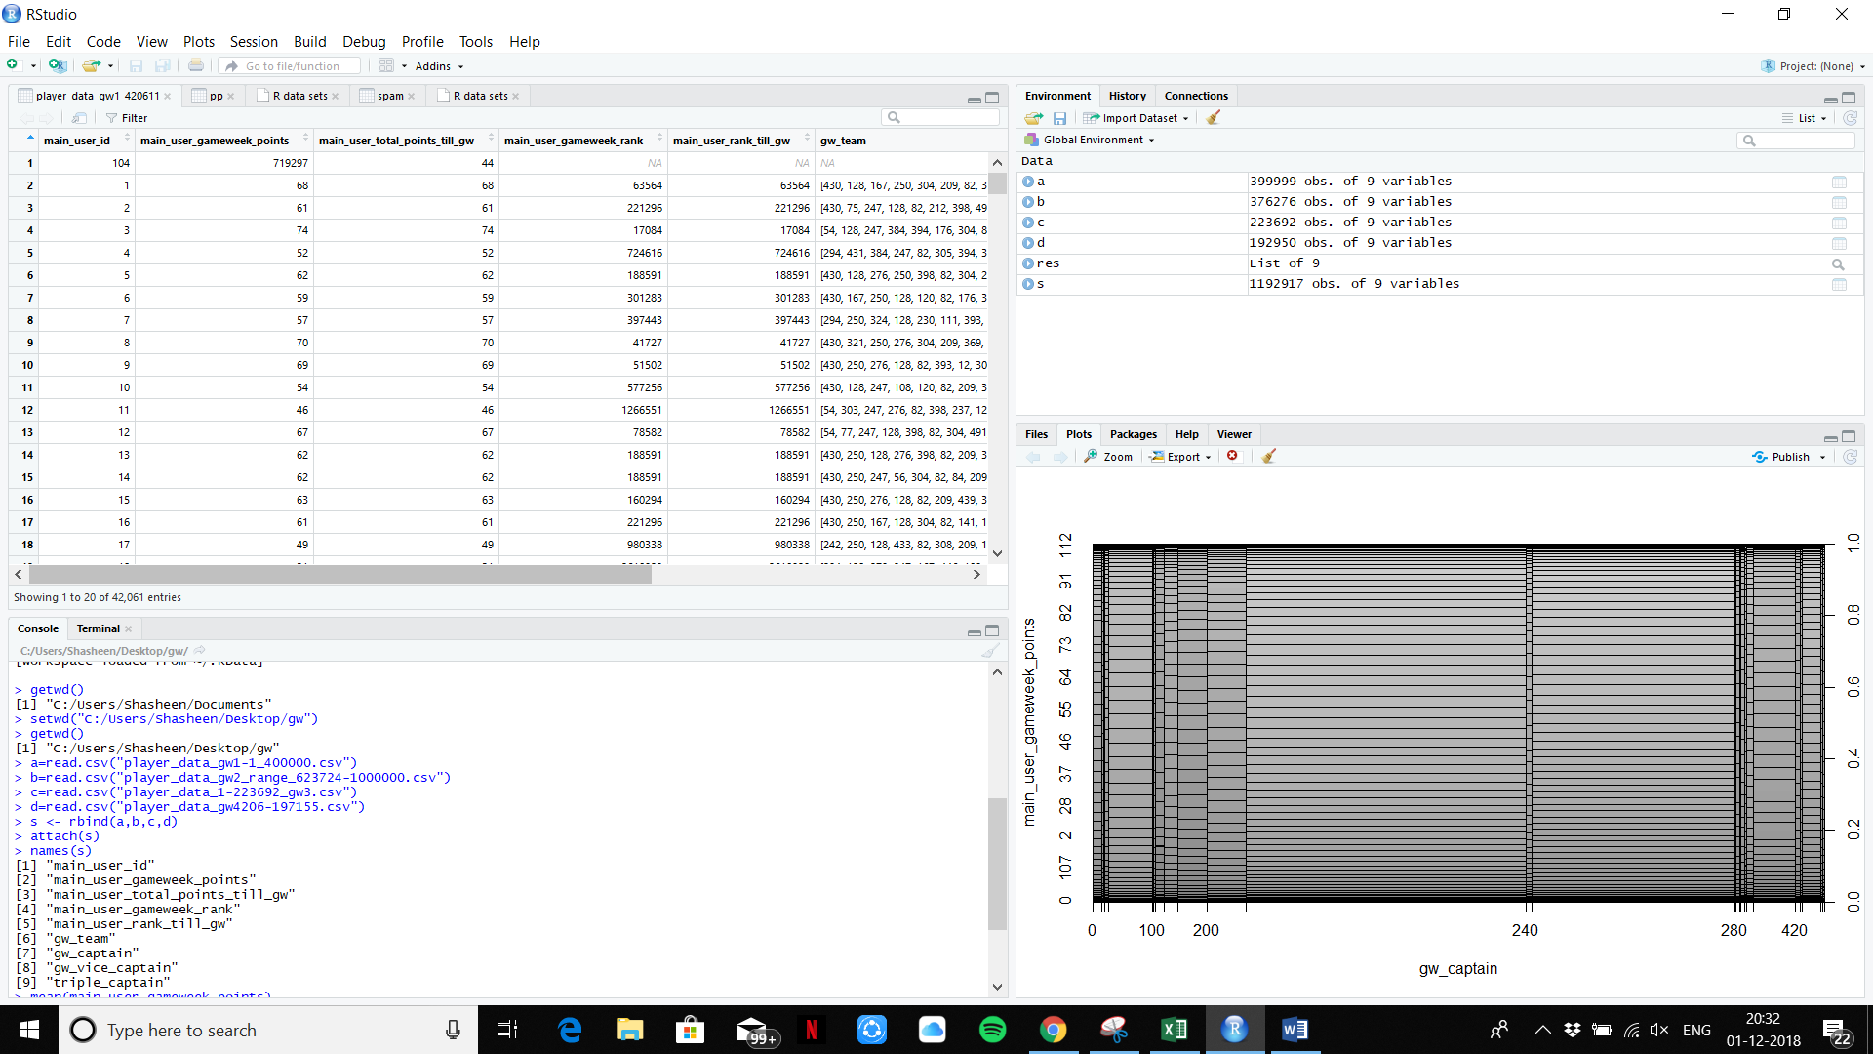

After binding 4 game week csv files we merge them into ne names as “S”.

Plotting main_user_gameweek_points~gw_captain

This shows the number of user points and compares them with the users who have significantly got more or less points because they captained a particular player and that player either performed very well for them or did not perform as good as they wanted him to.

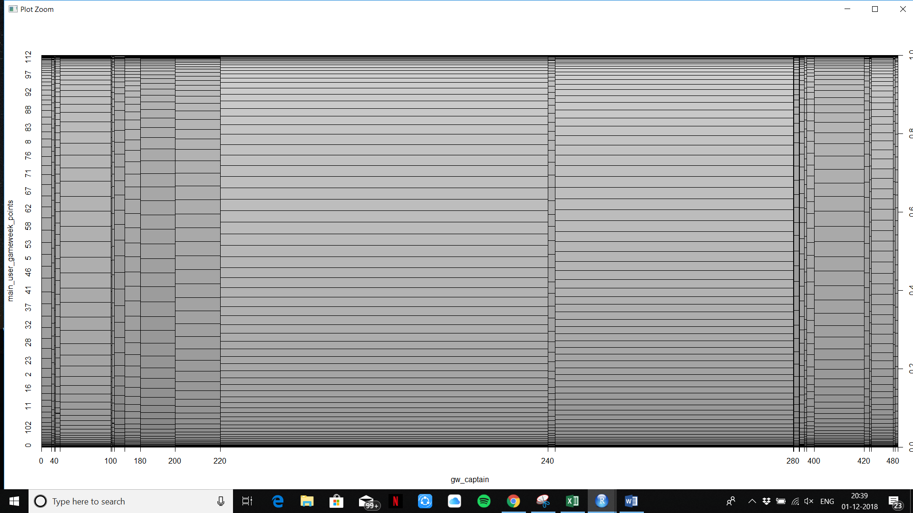

The Summary for the particular merged files “s”

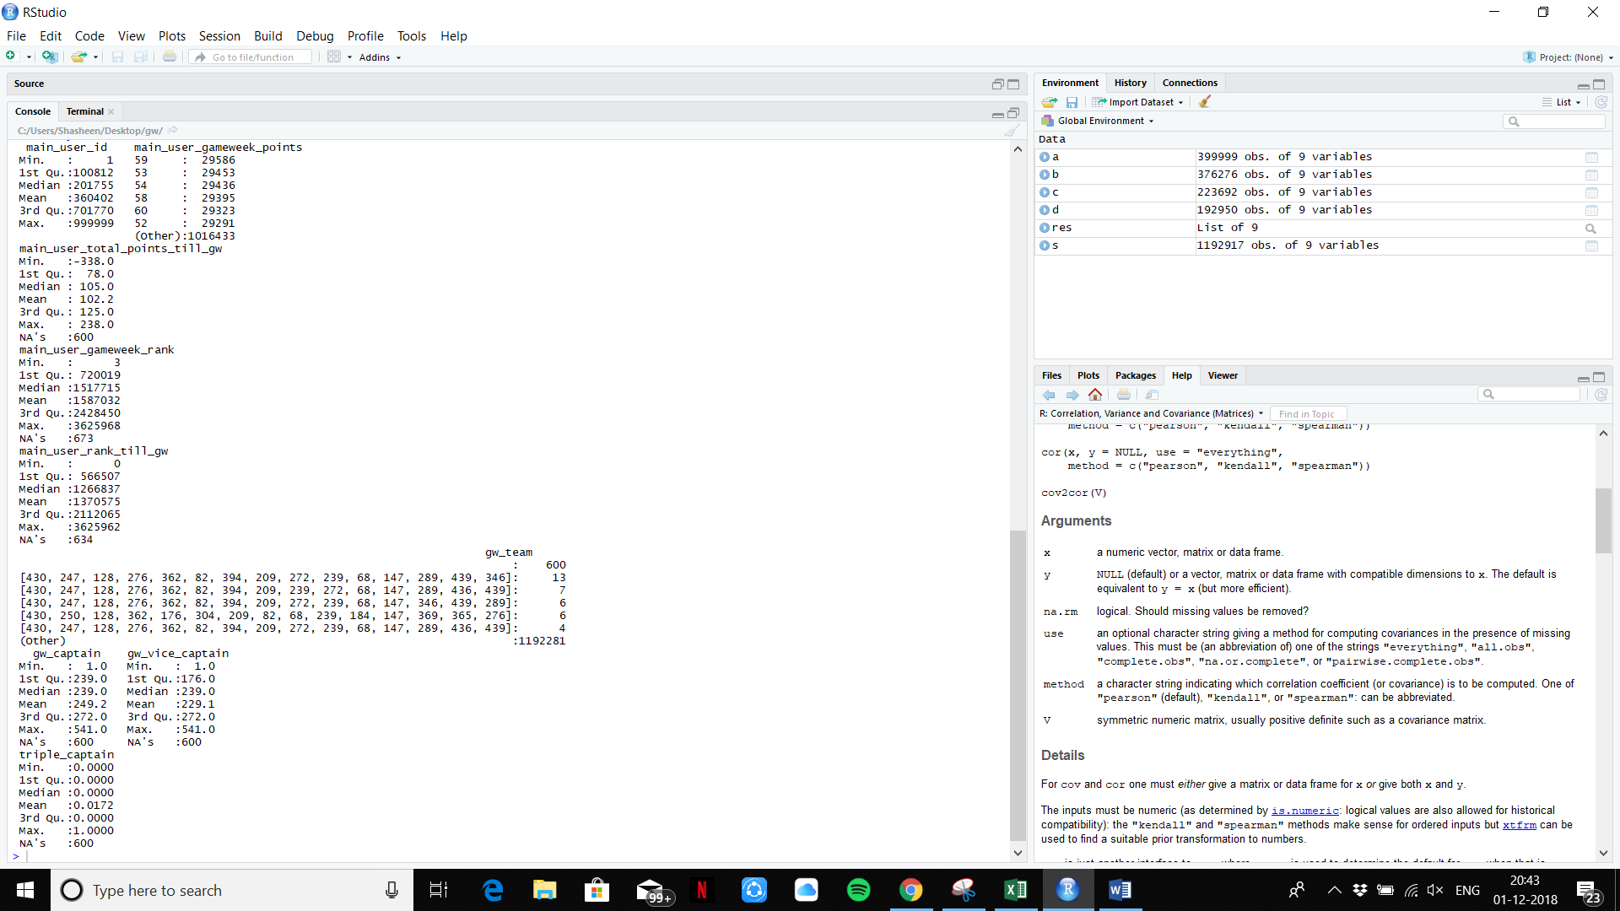

From the summary we can analyse that over 29395 users have got a means game week score of “58” over the four game weeks.

The median was a score of 54 for the four game weeks.

We can also see that almost 250 users had a success rate of getting a higher score by captaining a player that was effective for their team. And almost 230 users were successful by vice captaining an effective player.

Note – The Captain and the Vice captain roles play a big part as if a player who is captain or Vice captained scores a goal, his tally is doubled.

For eg A goals gives you 6 points and an assist gives you 3 points. So if a player has scored two goals and an assist, that takes his tally to

2x(2x6+1x3)= 30 when captained or vice captained. So the individual role of a player plays a massive a part.

The following is a box plot for (main_user_gameweek_rank,gw_captain)

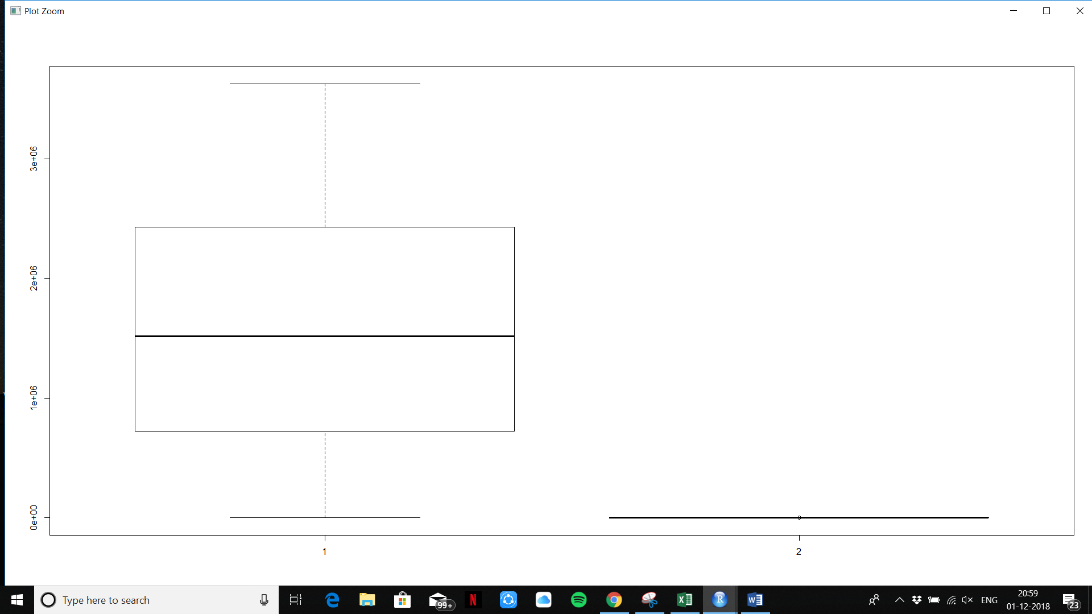

Applying Single linear model.

I was facing Trouble with inconsistent data with individual columns applying single linear model as there were some entries with no data and some with no entries ‘NA’. So I had to clean the data.

s[which(gw_captain=="-"),]

s[which(main_user_gameweek_points=="-"),]

for the specific columns.

> gw_captain=as.numeric(gw_captain)

> main_user_gameweek_points=as.numeric(main_user_gameweek_points)

> m=lm(main_user_gameweek_points~gw_captain)

> abline(coef(m)[1],coef(m)[2])

> summary(lm(main_user_gameweek_points~gw_captain))

Call:

lm(formula = main_user_gameweek_points ~ gw_captain)

Residuals:

Min 1Q Median 3Q Max

-58.452 -11.378 0.187 11.187 52.187

Coefficients:

Estimate Std. Error t value Pr(>|t|)

(Intercept) 5.815e+01 4.436e-02 1310.9 <2e-16

gw_captain 2.769e-03 1.688e-04 16.4 <2e-16

(Intercept) ***

gw_captain ***

---

Signif. codes:

0 ‘***’ 0.001 ‘**’ 0.01 ‘*’ 0.05 ‘.’ 0.1 ‘ ’ 1

Residual standard error: 15.34 on 1192315 degrees of freedom

(600 observations deleted due to missingness)

Multiple R-squared: 0.0002256, **Adjusted R-squared: 0.0002248**

F-statistic: 269.1 on 1 and 1192315 DF, p-value: < 2.2e-16

The Adjusted R-squared value is very small. A standard error of just 15.34

The lower the Rsquared value the better for the calculations.

**Multiple Linear Model.**

> m=lm(main_user_gameweek_points~gw_captain+gw_vice_captain+triple_captain)

> summary(m)

Call:

lm(formula = main_user_gameweek_points ~ gw_captain + gw_vice_captain +

triple_captain)

Residuals:

Min 1Q Median 3Q Max

-62.007 -11.358 0.222 11.290 52.235

Coefficients:

Estimate Std. Error t value

(Intercept) 5.795e+01 5.198e-02 1114.68

gw_captain 2.751e-03 1.687e-04 16.30

gw_vice_captain 5.907e-04 1.186e-04 4.98

triple_captain 4.244e+00 1.079e-01 39.34

Pr(>|t|)

(Intercept) < 2e-16 ***

gw_captain < 2e-16 ***

gw_vice_captain 6.36e-07 ***

triple_captain < 2e-16 ***

---

Signif. codes:

0 ‘***’ 0.001 ‘**’ 0.01 ‘*’ 0.05 ‘.’ 0.1 ‘ ’ 1

Residual standard error: 15.33 on 1192313 degrees of freedom

(600 observations deleted due to missingness)

Multiple R-squared: 0.001543, **Adjusted R-squared: 0.00154**

F-statistic: 614.1 on 3 and 1192313 DF, p-value: < 2.2e-16

The Adjusted R-squared value is very small but comparatively a bit larger. A standard error of just 15.34 and is the same as the single linear model.

Plotting:

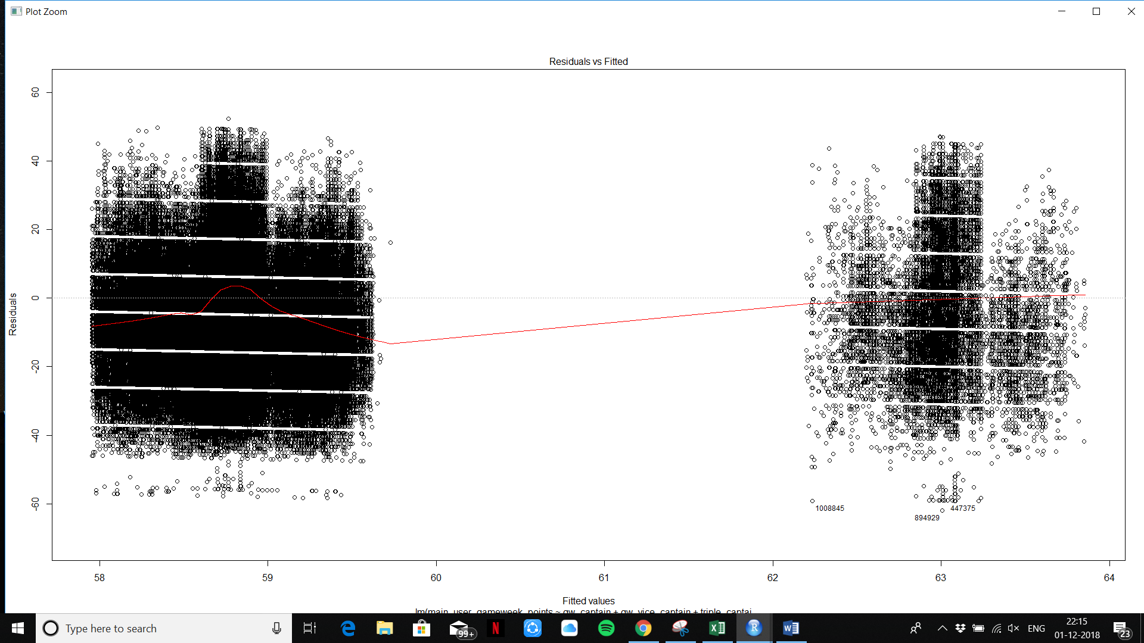

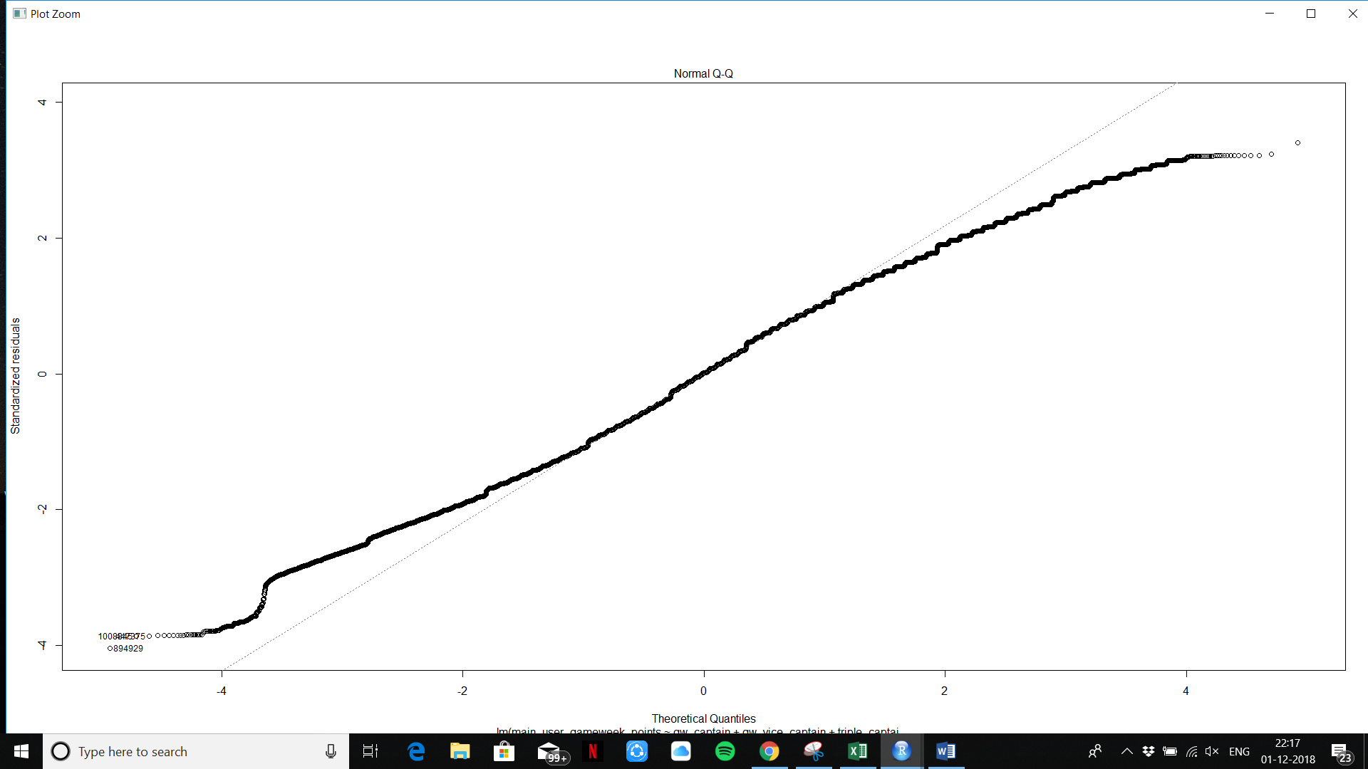

Applying general linear model(glm) Applying for 4 game weeks

> s$main_user_gameweek_points=factor(s$main_user_gameweek_points)

> b=glm(main_user_gameweek_points~gw_captain+gw_vice_captain+triple_captain,data=s,family = binomial)

> summary(b)

Call:

glm(formula = main_user_gameweek_points ~ gw_captain + gw_vice_captain +

triple_captain, family = binomial, data = s)

Deviance Residuals:

Min 1Q Median 3Q Max

-5.3386 0.0034 0.0039 0.0046 0.0370

Coefficients:

Estimate Std. Error z value

(Intercept) 9.566847 0.794202 12.046

gw_captain 0.010635 0.002853 3.728

gw_vice_captain -0.001667 0.002234 -0.746

triple_captain -1.502942 1.037750 -1.448

Pr(>|z|)

(Intercept) < 2e-16 ***

gw_captain 0.000193 ***

gw_vice_captain 0.455611

triple_captain 0.147542

The lower the value of P the better the result .In the case of vice_captain does not give a significant contribution. 45% for vice_captain. 45% of the value is completely random and high. The best values are the ones that are close to zero and as you can see in the result gw_captain has a much greater significance.

---

Signif. codes:

0 ‘***’ 0.001 ‘**’ 0.01 ‘*’ 0.05 ‘.’ 0.1 ‘ ’ 1

(Dispersion parameter for binomial family taken to be 1)

Null deviance: 345.87 on 1192316 degrees of freedom

Residual deviance: 331.40 on 1192313 degrees of freedom

(600 observations deleted due to missingness)

AIC: 339.4

**Number of Fisher Scoring iterations: 14**

**Applying Clustering Algorithms – KMEANS**

Plotting plot(s$main_user_gameweek_points,s$gw_captain)

I need to plot labels and explain.**

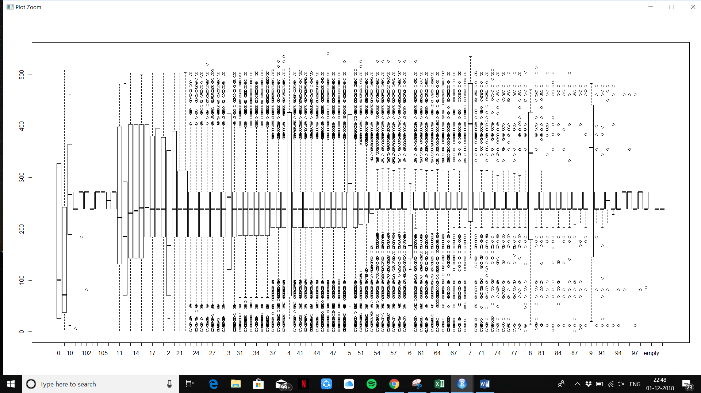

> head(s)

main_user_id main_user_gameweek_points

1 1 58

2 2 65

3 3 76

4 4 67

5 5 58

6 6 58

main_user_total_points_till_gw

1 126

2 126

3 142

4 119

5 120

6 117

main_user_gameweek_rank main_user_rank_till_gw

1 1721874 296242

2 1058180 309468

3 268297 46635

4 865676 572425

5 1721874 509674

6 1721874 643569

gw_team

1 [430, 128, 431, 250, 304, 209, 82, 393, 68, 239, 184, 147, 416, 276, 167]

2 [430, 75, 247, 128, 82, 134, 398, 491, 239, 184, 68, 147, 439, 276, 362]

3 [54, 436, 247, 384, 362, 267, 176, 304, 82, 239, 355, 274, 128, 49, 416]

4 [339, 363, 384, 247, 82, 305, 394, 134, 403, 239, 313, 294, 431, 148, 418]

5 [430, 128, 276, 250, 398, 82, 304, 209, 68, 239, 184, 147, 416, 197, 346]

6 [430, 362, 250, 128, 120, 82, 176, 308, 68, 239, 184, 147, 276, 167, 439]

gw_captain gw_vice_captain triple_captain

1 239 82 0

2 239 82 0

3 239 267 0

4 239 82 0

5 239 184 0

6 239 184 0

> sum(!sapply(s,is.finite))

[1] 3707

> sum(!sapply(s,is.nan))

[1] 10736253

**Plot for 4 clusters**

> plot(pp$main_user_gameweek_points, pp$gw_vice_captain)

> kmeans(data.frame(pp$main_user_gameweek_points, pp$gw_vice_captain), centers = 4, nstart = 20)

K-means clustering with 4 clusters of sizes 100160, 49870, 95280, 175290

Cluster means:

 pp.main_user_gameweek_points pp.gw_vice_captain

1                     505.77177 660.25619

2                     450.61640 4106.41789

3                     500.36734 1084.45823

4                     509.60294 2620.40265

Clustering vector:

  [1] 1 1 1 1 3 3 4 3 3 2 3 3 1 1 3 3 3 4 1 3 1 3 4 4 4 1 4 4 3 4 1 4 1 4 4 1 3 3 2 4 1 3 3 2 4 2 4 4 4 4 4 3 3 4 3 4 4

 [58] 3 1 1 3 3 1 1 4 1 1 1 3 4 4 4 3 4 3 1 2 4 3 3 3 1 4 1 3 3 3 3 4 3 4 4 3 1 3 4 1 1 3 3 1 3 2 3 1 4 3 3 4 3 4 4 3 4

[115] 1 4 4 4 3 3 1 4 4 1 1 2 4 1 1 1 1 3 4 3 4 4 2 4 3 3 4 4 3 1 1 3 3 1 3 1 4 4 3 1 2 4 3 4 2 1 3 3 3 4 2 1 1 1 4 4 2

[172] 1 3 3 1 1 4 4 1 3 4 1 4 3 1 4 1 4 4 2 4 4 3 1 4 4 1 3 4 4 4 1 4 3 4 1 4 4 4 4 4 3 1 1 4 4 4 1 3 2 4 4 1 1 4 4 3 1

[229] 2 3 2 4 4 4 4 1 3 3 1 3 1 3 4 1 1 3 1 1 3 4 3 2 4 1 2 3 4 4 4 4 4 3 4 4 1 4 3 4 3 3 3 4 1 4 3 2 3 4 4 4 4 3 3 3 3

[286] 1 3 2 1 4 3 2 4 3 4 4 3 4 3 4 4 4 3 4 3 3 3 4 2 4 3 4 3 1 4 3 4 4 1 4 3 3 4 4 4 4 1 1 3 1 1 4 4 1 4 1 4 4 3 1 1 4

[343] 3 2 1 3 3 4 2 2 1 1 4 3 2 3 4 3 1 1 4 4 3 3 4 3 1 2 4 2 1 1 4 1 3 3 4 4 3 3 4 1 4 3 4 4 4 4 4 2 4 3 2 3 3 1 4 3 1

[400] 3 3 1 2 4 4 3 4 1 1 3 1 1 4 1 3 1 2 3 4 3 4 4 1 4 4 3 4 3 4 2 4 3 3 3 1 3 4 4 1 3 3 4 4 1 2 4 3 1 3 1 3 4 1 3 1 4

[457] 3 4 1 3 3 4 1 4 4 2 1 4 4 1 2 4 4 2 3 1 2 1 4 3 1 1 3 1 1 1 4 4 2 1 1 3 1 3 3 1 3 3 4 1 3 3 3 3 4 4 4 3 4 1 3 3 4

[514] 1 3 1 1 4 1 4 3 4 1 4 2 3 4 4 3 2 3 2 4 3 1 1 1 1 2 4 3 3 4 3 4 3 4 3 1 1 3 1 1 3 1 4 1 1 4 1 4 2 1 4 4 4 1 4 4 4

[571] 4 1 1 2 2 3 3 1 1 3 4 1 4 3 1 1 2 1 2 3 4 1 4 4 3 4 1 1 1 4 1 3 1 4 3 1 4 1 4 4 4 3 3 1 1 4 4 1 1 2 4 3 4 3 3 4 3

[628] 4 3 1 2 4 1 4 1 4 3 4 1 1 3 1 1 3 3 1 1 3 4 3 4 3 3 4 2 2 4 2 3 4 1 2 4 1 4 4 4 1 1 4 1 3 4 2 3 3 4 1 1 4 4 1 3 2

[685] 4 3 4 3 1 4 4 1 1 1 1 2 1 1 4 4 3 1 4 4 3 1 1 3 3 1 1 4 1 4 4 1 3 4 1 3 4 2 4 4 2 3 1 3 1 1 1 4 4 4 1 4 3 3 4 1 3

[742] 2 4 3 4 4 4 2 1 3 1 1 4 1 3 3 2 1 1 3 3 4 4 2 4 2 3 1 3 4 4 1 1 3 3 1 3 3 3 4 3 3 3 2 3 4 1 3 1 3 4 4 3 2 3 4 3 3

[799] 4 4 1 3 1 3 4 3 4 1 3 3 3 4 3 4 4 4 4 4 1 2 4 4 3 4 3 3 4 4 4 1 2 4 4 3 1 3 1 4 1 3 3 4 3 3 2 3 3 4 2 3 1 2 1 1 4

[856] 4 4 1 4 1 1 1 4 3 1 1 3 4 3 4 2 4 3 4 1 4 4 4 4 3 1 4 1 3 1 3 3 3 3 4 3 2 4 4 3 4 3 4 4 2 4 1 3 3 3 1 4 1 1 1 3 3

[913] 4 2 2 1 4 4 3 3 3 3 3 1 4 1 1 4 3 4 3 3 4 1 2 1 3 3 3 1 3 3 2 3 1 1 2 1 3 1 1 2 4 4 2 3 1 2 4 3 1 3 4 2 4 2 2 1 4

[970] 1 3 1 4 3 4 4 3 1 4 1 3 4 4 4 1 4 4 1 1 1 2 4 1 4 4 4 3 3 3 4

[ reached getOption("max.print") -- omitted 41060 entries ]

Within cluster sum of squares by cluster:

[1] 118435039  72223086 40902208 110892343

**(between_SS / total_SS =  93.1 %)**

93 % accuracy is very good for this dataset while computing for 4 clusters.

Available components:

[1] "cluster"      "centers" "totss"        "withinss" "tot.withinss" "betweenss"    "size"

[8] "iter"         "ifault"

> cluster = kmeans(data.frame(pp$main_user_gameweek_points, pp$gw_vice_captain), centers = 2, nstart = 20)

> plot(main_user_gameweek_points,gw_vice_captain, col=ifelse(cluster==1, "red", "blue"))

Error in ifelse(cluster == 1, "red", "blue") :

 (list) object cannot be coerced to type 'double'

> cluster

**K-means clustering with 2 clusters of sizes 176388, 244522**

Cluster means:

 pp.main_user_gameweek_points pp.gw_vice_captain

1                     590.85832 1194.3376

2                     490.37757 2898.9347

Clustering vector:

  [1] 1 1 1 1 1 1 2 1 1 2 1 1 1 1 1 1 1 2 1 1 1 1 2 2 2 1 2 2 1 2 1 2 1 2 2 1 1 1 2 2 1 1 1 2 2 2 2 2 2 2 2 1 1 2 1 2 2

 [58] 1 1 1 1 1 1 1 2 1 1 1 1 2 2 2 1 2 1 1 2 2 1 1 1 1 2 1 1 1 1 1 2 1 2 2 1 1 1 2 1 1 1 1 1 1 2 1 1 2 1 1 2 1 2 2 1 2

[115] 1 2 2 2 1 1 1 2 2 1 1 2 2 1 1 1 1 1 2 1 2 2 2 2 1 1 2 2 1 1 1 1 1 1 1 1 2 2 1 1 2 2 1 2 2 1 1 1 1 2 2 1 1 1 2 2 2

[172] 1 1 1 1 1 2 2 1 1 2 1 2 1 1 2 1 2 2 2 2 2 1 1 2 2 1 1 2 2 2 1 2 1 2 1 2 2 2 2 2 1 1 1 2 2 2 1 1 2 2 2 1 1 2 2 1 1

[229] 2 1 2 2 2 2 2 1 1 1 1 1 1 1 2 1 1 1 1 1 1 2 2 2 2 1 2 1 2 2 2 2 2 1 2 2 1 2 1 2 1 1 1 2 1 2 1 2 1 2 2 2 2 1 1 1 1

[286] 1 1 2 1 2 1 2 2 1 2 2 1 2 1 2 2 2 1 2 1 1 1 2 2 2 1 2 1 1 2 1 2 2 1 2 1 1 2 2 2 2 1 1 1 1 1 2 2 1 2 1 2 2 1 1 1 2

[343] 1 2 1 1 1 2 2 2 1 1 2 1 2 1 2 1 1 1 2 2 1 1 2 1 1 2 2 2 1 1 2 1 1 1 2 2 1 1 2 1 2 1 2 2 2 2 2 2 2 1 2 1 1 1 2 1 1

[400] 1 1 1 2 2 2 1 2 1 1 1 1 1 2 1 1 1 2 1 2 1 2 2 1 2 2 1 2 1 2 2 2 2 1 1 1 1 2 2 1 1 2 2 2 1 2 2 1 1 1 1 1 2 1 1 1 2

[457] 1 2 1 1 1 2 1 2 2 2 1 2 2 1 2 2 2 2 1 1 2 1 2 1 1 1 1 1 1 1 2 2 2 1 1 1 1 1 1 1 1 1 2 1 1 1 1 1 2 2 2 1 2 1 1 1 2

[514] 1 1 1 1 2 1 2 1 2 1 2 2 1 2 2 1 2 1 2 2 2 1 1 1 1 2 2 1 1 2 1 2 1 2 1 1 1 1 1 1 1 1 2 1 1 2 1 2 2 1 2 2 2 1 2 2 2

[571] 2 1 1 2 2 1 1 1 1 1 2 1 2 1 1 1 2 1 2 1 2 1 2 2 1 2 1 1 1 2 1 1 1 2 1 1 2 1 2 2 2 1 1 1 1 2 2 1 1 2 2 1 2 1 1 2 1

[628] 2 2 1 2 2 1 2 1 2 1 2 1 1 1 1 1 1 1 1 1 1 2 2 2 1 1 2 2 2 2 2 2 2 1 2 2 1 2 2 2 1 1 2 1 1 2 2 1 1 2 1 1 2 2 1 1 2

[685] 2 1 2 1 1 2 2 1 1 1 1 2 1 1 2 2 1 1 2 2 1 1 1 1 1 1 1 2 1 2 2 1 1 2 1 1 2 2 2 2 2 1 1 1 1 1 1 2 2 2 1 2 1 1 2 1 1

[742] 2 2 1 2 2 2 2 1 1 1 1 2 1 2 2 2 1 1 1 1 2 2 2 2 2 1 1 1 2 2 1 1 1 1 1 1 1 1 2 1 1 1 2 1 2 1 1 1 1 2 2 1 2 1 2 1 1

[799] 2 2 1 1 1 1 2 1 2 1 1 1 1 2 1 2 2 2 2 2 1 2 2 2 1 2 1 1 2 2 2 1 2 2 2 1 1 1 1 2 1 1 1 2 1 1 2 1 1 2 2 1 1 2 1 1 2

[856] 2 2 1 2 1 1 1 2 1 1 1 1 2 1 2 2 2 1 2 1 2 2 2 2 2 1 2 1 1 1 1 1 1 1 2 1 2 2 2 1 2 1 2 2 2 2 1 2 1 1 1 2 1 1 1 1 1

[913] 2 2 2 1 2 2 1 1 2 1 1 1 2 1 1 2 1 2 1 2 2 1 2 1 1 1 1 1 1 2 2 1 1 1 2 1 1 1 1 2 2 2 2 1 1 2 2 1 1 1 2 2 2 2 2 1 2

[970] 1 1 1 2 1 2 2 1 1 2 1 2 2 2 2 1 2 2 1 1 1 2 2 1 2 2 2 1 2 2 2

[ reached getOption("max.print") -- omitted 41060 entries ]

Within cluster sum of squares by cluster:

[1]  673630849 1241079804

(between_SS / total_SS =  62.3 %)

Available components:

[1] "cluster"      "centers" "totss"        "withinss" "tot.withinss" "betweenss"    "size"

[8] "iter"         "ifault"

> cluster[0]

named list()

> cluster[1]

$`cluster`

  [1] 1 1 1 1 1 1 2 1 1 2 1 1 1 1 1 1 1 2 1 1 1 1 2 2 2 1 2 2 1 2 1 2 1 2 2 1 1 1 2 2 1 1 1 2 2 2 2 2 2 2 2 1 1 2 1 2 2

 [58] 1 1 1 1 1 1 1 2 1 1 1 1 2 2 2 1 2 1 1 2 2 1 1 1 1 2 1 1 1 1 1 2 1 2 2 1 1 1 2 1 1 1 1 1 1 2 1 1 2 1 1 2 1 2 2 1 2

[115] 1 2 2 2 1 1 1 2 2 1 1 2 2 1 1 1 1 1 2 1 2 2 2 2 1 1 2 2 1 1 1 1 1 1 1 1 2 2 1 1 2 2 1 2 2 1 1 1 1 2 2 1 1 1 2 2 2

[172] 1 1 1 1 1 2 2 1 1 2 1 2 1 1 2 1 2 2 2 2 2 1 1 2 2 1 1 2 2 2 1 2 1 2 1 2 2 2 2 2 1 1 1 2 2 2 1 1 2 2 2 1 1 2 2 1 1

[229] 2 1 2 2 2 2 2 1 1 1 1 1 1 1 2 1 1 1 1 1 1 2 2 2 2 1 2 1 2 2 2 2 2 1 2 2 1 2 1 2 1 1 1 2 1 2 1 2 1 2 2 2 2 1 1 1 1

[286] 1 1 2 1 2 1 2 2 1 2 2 1 2 1 2 2 2 1 2 1 1 1 2 2 2 1 2 1 1 2 1 2 2 1 2 1 1 2 2 2 2 1 1 1 1 1 2 2 1 2 1 2 2 1 1 1 2

[343] 1 2 1 1 1 2 2 2 1 1 2 1 2 1 2 1 1 1 2 2 1 1 2 1 1 2 2 2 1 1 2 1 1 1 2 2 1 1 2 1 2 1 2 2 2 2 2 2 2 1 2 1 1 1 2 1 1

[400] 1 1 1 2 2 2 1 2 1 1 1 1 1 2 1 1 1 2 1 2 1 2 2 1 2 2 1 2 1 2 2 2 2 1 1 1 1 2 2 1 1 2 2 2 1 2 2 1 1 1 1 1 2 1 1 1 2

[457] 1 2 1 1 1 2 1 2 2 2 1 2 2 1 2 2 2 2 1 1 2 1 2 1 1 1 1 1 1 1 2 2 2 1 1 1 1 1 1 1 1 1 2 1 1 1 1 1 2 2 2 1 2 1 1 1 2

[514] 1 1 1 1 2 1 2 1 2 1 2 2 1 2 2 1 2 1 2 2 2 1 1 1 1 2 2 1 1 2 1 2 1 2 1 1 1 1 1 1 1 1 2 1 1 2 1 2 2 1 2 2 2 1 2 2 2

[571] 2 1 1 2 2 1 1 1 1 1 2 1 2 1 1 1 2 1 2 1 2 1 2 2 1 2 1 1 1 2 1 1 1 2 1 1 2 1 2 2 2 1 1 1 1 2 2 1 1 2 2 1 2 1 1 2 1

[628] 2 2 1 2 2 1 2 1 2 1 2 1 1 1 1 1 1 1 1 1 1 2 2 2 1 1 2 2 2 2 2 2 2 1 2 2 1 2 2 2 1 1 2 1 1 2 2 1 1 2 1 1 2 2 1 1 2

[685] 2 1 2 1 1 2 2 1 1 1 1 2 1 1 2 2 1 1 2 2 1 1 1 1 1 1 1 2 1 2 2 1 1 2 1 1 2 2 2 2 2 1 1 1 1 1 1 2 2 2 1 2 1 1 2 1 1

[742] 2 2 1 2 2 2 2 1 1 1 1 2 1 2 2 2 1 1 1 1 2 2 2 2 2 1 1 1 2 2 1 1 1 1 1 1 1 1 2 1 1 1 2 1 2 1 1 1 1 2 2 1 2 1 2 1 1

[799] 2 2 1 1 1 1 2 1 2 1 1 1 1 2 1 2 2 2 2 2 1 2 2 2 1 2 1 1 2 2 2 1 2 2 2 1 1 1 1 2 1 1 1 2 1 1 2 1 1 2 2 1 1 2 1 1 2

[856] 2 2 1 2 1 1 1 2 1 1 1 1 2 1 2 2 2 1 2 1 2 2 2 2 2 1 2 1 1 1 1 1 1 1 2 1 2 2 2 1 2 1 2 2 2 2 1 2 1 1 1 2 1 1 1 1 1

[913] 2 2 2 1 2 2 1 1 2 1 1 1 2 1 1 2 1 2 1 2 2 1 2 1 1 1 1 1 1 2 2 1 1 1 2 1 1 1 1 2 2 2 2 1 1 2 2 1 1 1 2 2 2 2 2 1 2

[970] 1 1 1 2 1 2 2 1 1 2 1 2 2 2 2 1 2 2 1 1 1 2 2 1 2 2 2 1 2 2 2

[ reached getOption("max.print") -- omitted 41060 entries ]

> cluster$cluster

  [1] 1 1 1 1 1 1 2 1 1 2 1 1 1 1 1 1 1 2 1 1 1 1 2 2 2 1 2 2 1 2 1 2 1 2 2 1 1 1 2 2 1 1 1 2 2 2 2 2 2 2 2 1 1 2 1 2 2

 [58] 1 1 1 1 1 1 1 2 1 1 1 1 2 2 2 1 2 1 1 2 2 1 1 1 1 2 1 1 1 1 1 2 1 2 2 1 1 1 2 1 1 1 1 1 1 2 1 1 2 1 1 2 1 2 2 1 2

[115] 1 2 2 2 1 1 1 2 2 1 1 2 2 1 1 1 1 1 2 1 2 2 2 2 1 1 2 2 1 1 1 1 1 1 1 1 2 2 1 1 2 2 1 2 2 1 1 1 1 2 2 1 1 1 2 2 2

[172] 1 1 1 1 1 2 2 1 1 2 1 2 1 1 2 1 2 2 2 2 2 1 1 2 2 1 1 2 2 2 1 2 1 2 1 2 2 2 2 2 1 1 1 2 2 2 1 1 2 2 2 1 1 2 2 1 1

[229] 2 1 2 2 2 2 2 1 1 1 1 1 1 1 2 1 1 1 1 1 1 2 2 2 2 1 2 1 2 2 2 2 2 1 2 2 1 2 1 2 1 1 1 2 1 2 1 2 1 2 2 2 2 1 1 1 1

[286] 1 1 2 1 2 1 2 2 1 2 2 1 2 1 2 2 2 1 2 1 1 1 2 2 2 1 2 1 1 2 1 2 2 1 2 1 1 2 2 2 2 1 1 1 1 1 2 2 1 2 1 2 2 1 1 1 2

[343] 1 2 1 1 1 2 2 2 1 1 2 1 2 1 2 1 1 1 2 2 1 1 2 1 1 2 2 2 1 1 2 1 1 1 2 2 1 1 2 1 2 1 2 2 2 2 2 2 2 1 2 1 1 1 2 1 1

[400] 1 1 1 2 2 2 1 2 1 1 1 1 1 2 1 1 1 2 1 2 1 2 2 1 2 2 1 2 1 2 2 2 2 1 1 1 1 2 2 1 1 2 2 2 1 2 2 1 1 1 1 1 2 1 1 1 2

[457] 1 2 1 1 1 2 1 2 2 2 1 2 2 1 2 2 2 2 1 1 2 1 2 1 1 1 1 1 1 1 2 2 2 1 1 1 1 1 1 1 1 1 2 1 1 1 1 1 2 2 2 1 2 1 1 1 2

[514] 1 1 1 1 2 1 2 1 2 1 2 2 1 2 2 1 2 1 2 2 2 1 1 1 1 2 2 1 1 2 1 2 1 2 1 1 1 1 1 1 1 1 2 1 1 2 1 2 2 1 2 2 2 1 2 2 2

[571] 2 1 1 2 2 1 1 1 1 1 2 1 2 1 1 1 2 1 2 1 2 1 2 2 1 2 1 1 1 2 1 1 1 2 1 1 2 1 2 2 2 1 1 1 1 2 2 1 1 2 2 1 2 1 1 2 1

[628] 2 2 1 2 2 1 2 1 2 1 2 1 1 1 1 1 1 1 1 1 1 2 2 2 1 1 2 2 2 2 2 2 2 1 2 2 1 2 2 2 1 1 2 1 1 2 2 1 1 2 1 1 2 2 1 1 2

[685] 2 1 2 1 1 2 2 1 1 1 1 2 1 1 2 2 1 1 2 2 1 1 1 1 1 1 1 2 1 2 2 1 1 2 1 1 2 2 2 2 2 1 1 1 1 1 1 2 2 2 1 2 1 1 2 1 1

[742] 2 2 1 2 2 2 2 1 1 1 1 2 1 2 2 2 1 1 1 1 2 2 2 2 2 1 1 1 2 2 1 1 1 1 1 1 1 1 2 1 1 1 2 1 2 1 1 1 1 2 2 1 2 1 2 1 1

[799] 2 2 1 1 1 1 2 1 2 1 1 1 1 2 1 2 2 2 2 2 1 2 2 2 1 2 1 1 2 2 2 1 2 2 2 1 1 1 1 2 1 1 1 2 1 1 2 1 1 2 2 1 1 2 1 1 2

[856] 2 2 1 2 1 1 1 2 1 1 1 1 2 1 2 2 2 1 2 1 2 2 2 2 2 1 2 1 1 1 1 1 1 1 2 1 2 2 2 1 2 1 2 2 2 2 1 2 1 1 1 2 1 1 1 1 1

[913] 2 2 2 1 2 2 1 1 2 1 1 1 2 1 1 2 1 2 1 2 2 1 2 1 1 1 1 1 1 2 2 1 1 1 2 1 1 1 1 2 2 2 2 1 1 2 2 1 1 1 2 2 2 2 2 1 2

[970] 1 1 1 2 1 2 2 1 1 2 1 2 2 2 2 1 2 2 1 1 1 2 2 1 2 2 2 1 2 2 2

[ reached getOption("max.print") -- omitted 41060 entries ]

> plot(main_user_gameweek_points,gw_vice_captain, col=ifelse(cluster$cluster==1, "red", "blue"))

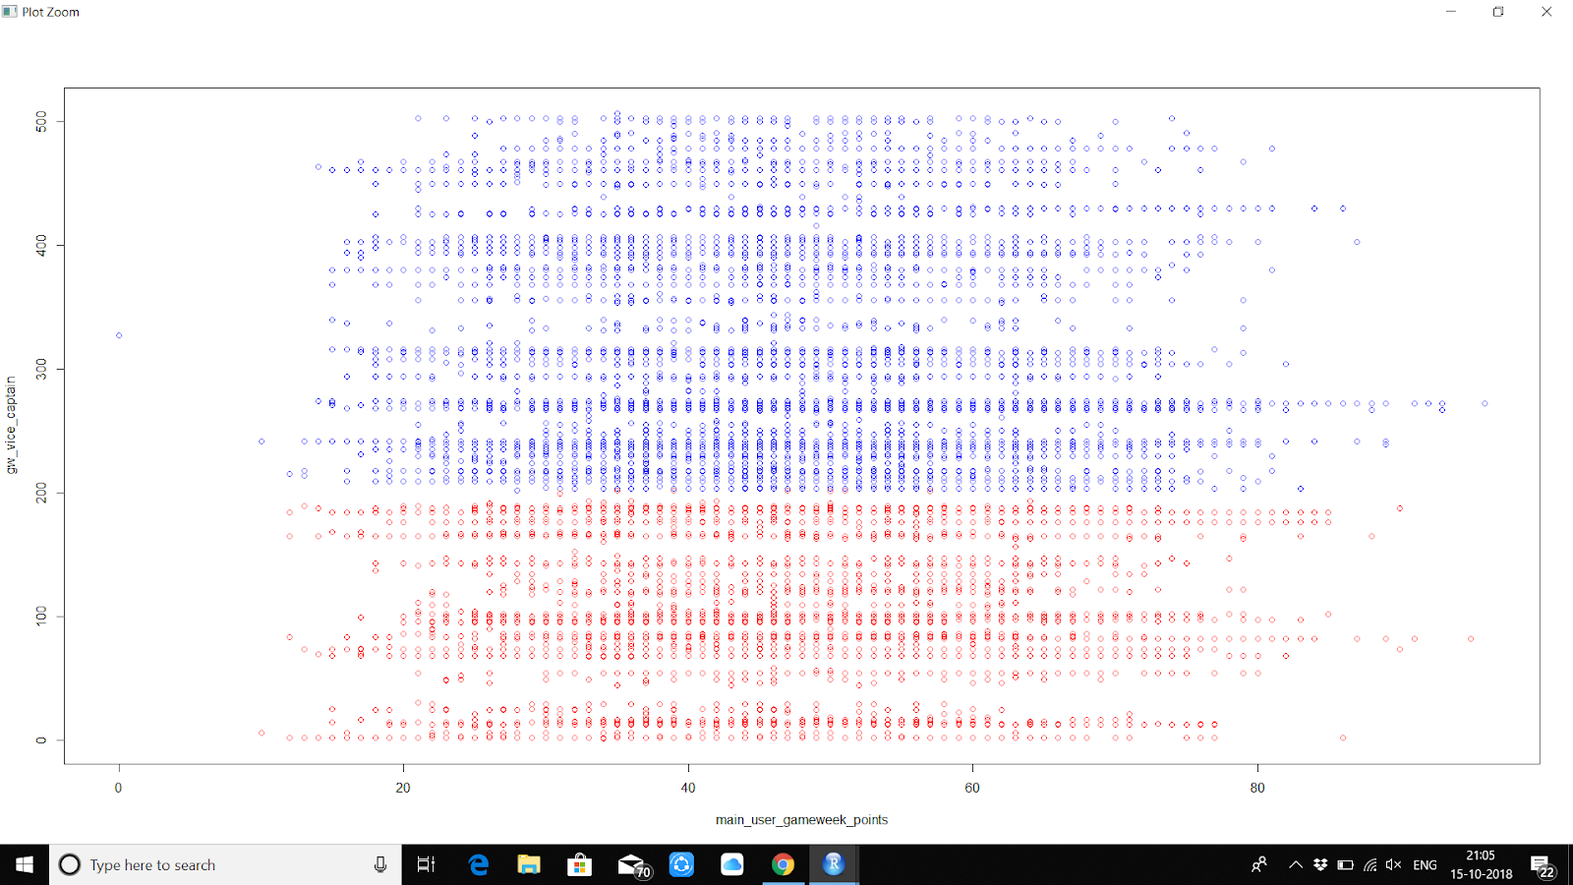

**As you can see with the graph. The data has no particular clustering center but is divided very clearly with the number of levels. This basically shows that the data is consistent through and fairly accurate. This is for 2 clusters.**

**Now for clusters.**

> cluster = kmeans(data.frame(pp$main_user_gameweek_points, pp$gw_vice_captain), centers = 4, nstart = 20)

> cluster$cluster

  [1] 4 4 4 4 1 1 2 1 1 3 1 1 4 4 1 1 1 2 4 1 4 1 2 2 2 4 2

 [28] 2 1 2 4 2 4 2 2 4 1 1 3 2 4 1 1 3 2 3 2 2 2 2 2 1 1 2

 [55] 1 2 2 1 4 4 1 1 4 4 2 4 4 4 1 2 2 2 1 2 1 4 3 2 1 1 1

 [82] 4 2 4 1 1 1 1 2 1 2 2 1 4 1 2 4 4 1 1 4 1 3 1 4 2 1 1

[109] 2 1 2 2 1 2 4 2 2 2 1 1 4 2 2 4 4 3 2 4 4 4 4 1 2 1 2

[136] 2 3 2 1 1 2 2 1 4 4 1 1 4 1 4 2 2 1 4 3 2 1 2 3 4 1 1

[163] 1 2 3 4 4 4 2 2 3 4 1 1 4 4 2 2 4 1 2 4 2 1 4 2 4 2 2

[190] 3 2 2 1 4 2 2 4 1 2 2 2 4 2 1 2 4 2 2 2 2 2 1 4 4 2 2

[217] 2 4 1 3 2 2 4 4 2 2 1 4 3 1 3 2 2 2 2 4 1 1 4 1 4 1 2

[244] 4 4 1 4 4 1 2 1 3 2 4 3 1 2 2 2 2 2 1 2 2 4 2 1 2 1 1

[271] 1 2 4 2 1 3 1 2 2 2 2 1 1 1 1 4 1 3 4 2 1 3 2 1 2 2 1

[298] 2 1 2 2 2 1 2 1 1 1 2 3 2 1 2 1 4 2 1 2 2 4 2 1 1 2 2

[325] 2 2 4 4 1 4 4 2 2 4 2 4 2 2 1 4 4 2 1 3 4 1 1 2 3 3 4

[352] 4 2 1 3 1 2 1 4 4 2 2 1 1 2 1 4 3 2 3 4 4 2 4 1 1 2 2

[379] 1 1 2 4 2 1 2 2 2 2 2 3 2 1 3 1 1 4 2 1 4 1 1 4 3 2 2

[406] 1 2 4 4 1 4 4 2 4 1 4 3 1 2 1 2 2 4 2 2 1 2 1 2 3 2 1

[433] 1 1 4 1 2 2 4 1 1 2 2 4 3 2 1 4 1 4 1 2 4 1 4 2 1 2 4

[460] 1 1 2 4 2 2 3 4 2 2 4 3 2 2 3 1 4 3 4 2 1 4 4 1 4 4 4

[487] 2 2 3 4 4 1 4 1 1 4 1 1 2 4 1 1 1 1 2 2 2 1 2 4 1 1 2

[514] 4 1 4 4 2 4 2 1 2 4 2 3 1 2 2 1 3 1 3 2 1 4 4 4 4 3 2

[541] 1 1 2 1 2 1 2 1 4 4 1 4 4 1 4 2 4 4 2 4 2 3 4 2 2 2 4

[568] 2 2 2 2 4 4 3 3 1 1 4 4 1 2 4 2 1 4 4 3 4 3 1 2 4 2 2

[595] 1 2 4 4 4 2 4 1 4 2 1 4 2 4 2 2 2 1 1 4 4 2 2 4 4 3 2

[622] 1 2 1 1 2 1 2 1 4 3 2 4 2 4 2 1 2 4 4 1 4 4 1 1 4 4 1

[649] 2 1 2 1 1 2 3 3 2 3 1 2 4 3 2 4 2 2 2 4 4 2 4 1 2 3 1

[676] 1 2 4 4 2 2 4 1 3 2 1 2 1 4 2 2 4 4 4 4 3 4 4 2 2 1 4

[703] 2 2 1 4 4 1 1 4 4 2 4 2 2 4 1 2 4 1 2 3 2 2 3 1 4 1 4

[730] 4 4 2 2 2 4 2 1 1 2 4 1 3 2 1 2 2 2 3 4 1 4 4 2 4 1 1

[757] 3 4 4 1 1 2 2 3 2 3 1 4 1 2 2 4 4 1 1 4 1 1 1 2 1 1 1

[784] 3 1 2 4 1 4 1 2 2 1 3 1 2 1 1 2 2 4 1 4 1 2 1 2 4 1 1

[811] 1 2 1 2 2 2 2 2 4 3 2 2 1 2 1 1 2 2 2 4 3 2 2 1 4 1 4

[838] 2 4 1 1 2 1 1 3 1 1 2 3 1 4 3 4 4 2 2 2 4 2 4 4 4 2 1

[865] 4 4 1 2 1 2 3 2 1 2 4 2 2 2 2 1 4 2 4 1 4 1 1 1 1 2 1

[892] 3 2 2 1 2 1 2 2 3 2 4 1 1 1 4 2 4 4 4 1 1 2 3 3 4 2 2

[919] 1 1 1 1 1 4 2 4 4 2 1 2 1 1 2 4 3 4 1 1 1 4 1 1 3 1 4

[946] 4 3 4 1 4 4 3 2 2 3 1 4 3 2 1 4 1 2 3 2 3 3 4 2 4 1 4

[973] 2 1 2 2 1 4 2 4 1 2 2 2 4 2 2 4 4 4 3 2 4 2 2 2 1 1 1

[1000] 2

[ reached getOption("max.print") -- omitted 41060 entries ]

> plot(main_user_gameweek_points,gw_vice_captain, col=ifelse(cluster$cluster==1, "red", ifelse (cluster$cluster==2,"blue", "green")))

> plot(main_user_gameweek_points,gw_vice_captain, col=ifelse(cluster$cluster==1, "red", ifelse (cluster$cluster==2,"blue", ifelse(cluster$cluster==3,"green","yellow" ))))

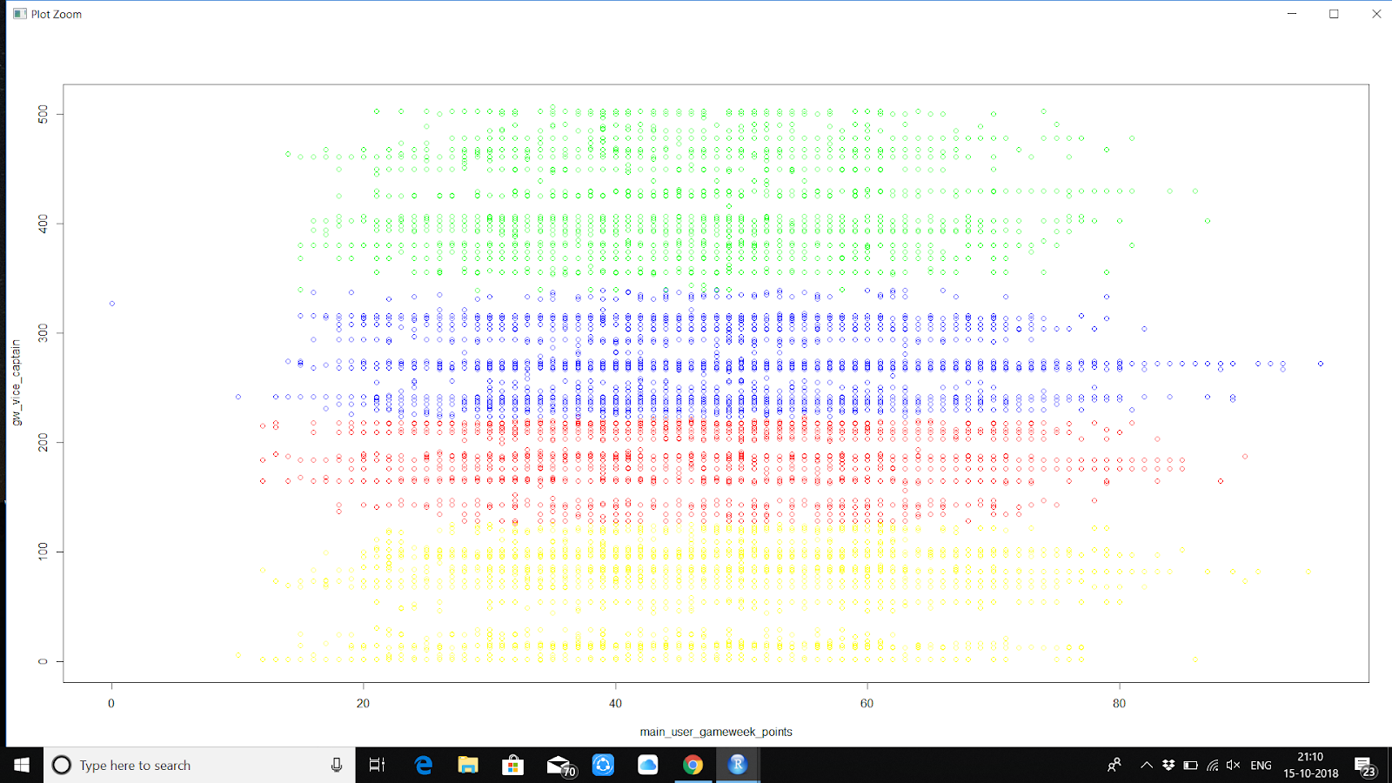

KNN-

The dataset I chose is not suited for knn because there are no clear categories that can be used as labels. The dataset that is used is clearly too big to compute Knn for train and test data can gives inconsistent data.

Naïve Bayes-

The dataset I’ve chosen is not suited for naïve Bayes as Naïve bayes requires binary data which consists mainly of 3 or less coloumn.